32nd meeting of the EASO Management Board held in Malta

* 18TH JUNE 2019

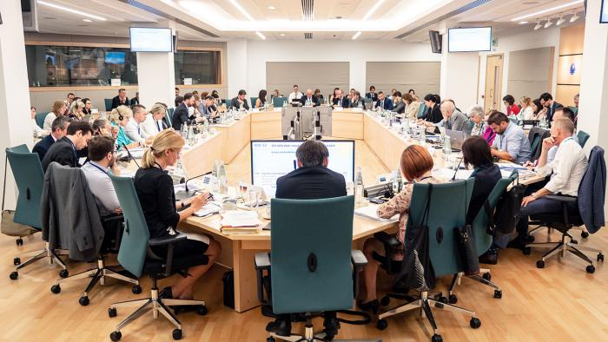

***Work taken to dramatically improve the governance of EASO over the past year is showing concrete results.***

The 32nd meeting of the EASO Management Board took place in Malta on 17-18 June 2019. The meeting was the first in which Ms. Nina Gregori attended as the new Executive Director of EASO, having taken up her duties on 16 June 2019. Ms. Gregori was previously the representative of Slovenia on the Management Board.

Dr. David Costello, who was elected at the last Management Board meeting on 18-19 February 2019, chaired the meeting.

In keeping with the ongoing focus of the Management Board to strengthen the governance mechanisms of the Agency, the meeting discussed the latest developments in the implementation of the EASO Governance Action Plan that was approved in 2018. Within this same context, the 2018 Consolidated Annual Activity Report and 2018 Annual General Report were also adopted.

The Management Board once again recognised the strong efforts and progress which has been made by EASO over the past year, including the efforts the former Executive Director *ad interim*, Mr. Jamil Addou, made in stewarding the process and achieving significant results. The Management Board also expressed their full confidence in, and appreciation for, Ms. Gregori’s strong commitment to take the process forward.

The meeting approved a procedure for the adoption of Country Guidance Notes, and in addition two new EASO Country Guidance reports, on Iraq and Afghanistan. Country Guidance reports aim at fostering convergence in the application of the criteria for qualification for international protection for specific countries of origin, based on common analysis and guidance notes of EU+ Member States. More information can be accessed [here](https://www.easo.europa.eu/country-guidance).

EASO’s Annual Report on the situation of asylum in the EU+ in 2018 was also adopted by the Management Board. The Report is a reference document that aims to provide a comprehensive overview of the situation of asylum in the EU+, describing and analysing flows of applicants for international protection, major developments in legislation, jurisprudence, and policies at EU+ and national level, and reporting on the practical functioning of the Common European Asylum System (CEAS).

The Annual Report will be launched at an event in Brussels on 24 June 2019. More information can be obtained [here](https://www.easo.europa.eu/easo-annual-report).